Constructing Spiral

Definition
# Source: AI Source: Provided by: [Data Path: Persons Table -> ID Column: 1, Name_En Column: Motasem Essam] -> From: [ChatGPT] on [7/25/2026]
Constructing a Spiral is the process of creating a curved geometric figure that continuously winds around a central point or axis while its distance from the center changes progressively.
A spiral generally has:
- A center or pole.
- A continuously changing distance from the center.
- A continuously changing direction.
- One or more turns around the center.
- A curved path that moves inward or outward.
Unlike a circle, a spiral does not maintain a constant distance from its center.

Fundamental Concept
# Source: AI Source: Provided by: [Data Path: Persons Table -> ID Column: 1, Name_En Column: Motasem Essam] -> From: [ChatGPT] on [7/25/2026]
For a point $P$moving along a spiral, its polar position can be described by:
$$\boxed{\left(r , θ\right)}$$
where:
- $r$= distance from the center.
- $θ$= angular position.
A spiral is therefore commonly represented by a relationship between $r$and $θ$:
$$\boxed{r=f\left(θ\right)}$$
The exact form of $f\left(θ\right)$determines the type of spiral.

Main Construction Principle
# Source: AI Source: Provided by: [Data Path: Persons Table -> ID Column: 1, Name_En Column: Motasem Essam] -> From: [ChatGPT] on [7/25/2026]
A spiral can be constructed by determining a sequence of points whose:
- Angular positions change progressively.
- Distances from the center change according to a chosen rule.
- Points are connected by a smooth curve.
General procedure:
- Mark the center $O$.
- Establish one or more reference axes.
- Divide the angular rotation into suitable intervals.
- Determine the required radius for each angle.
- Mark the corresponding points.
- Connect the points with a smooth continuous curve.
- Continue until the required number of turns is completed.

Types of Spiral Construction
# Source: AI Source: Provided by: [Data Path: Persons Table -> ID Column: 1, Name_En Column: Motasem Essam] -> From: [ChatGPT] on [7/25/2026]
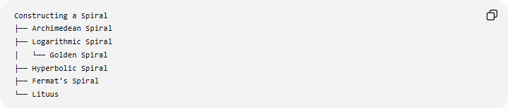
Constructing a Spiral
├── Archimedean Spiral
├── Logarithmic Spiral
│ └── Golden Spiral
├── Hyperbolic Spiral
├── Fermat's Spiral
└── Lituus
These are mathematical spiral families. Other names may describe particular constructions or applications rather than fundamental spiral families.

1. Constructing an Archimedean Spiral
# Source: AI Source: Provided by: [Data Path: Persons Table -> ID Column: 1, Name_En Column: Motasem Essam] -> From: [ChatGPT] on [7/25/2026]
Definition
An Archimedean spiral is a spiral in which the distance from the center changes at a constant rate with respect to the angle.
Its polar equation is:
$$\boxed{r=a+bθ}$$
where $a$and $b$are constants.
If $b>0$, the spiral moves outward as $θ$increases.

Construction
- Mark the center $O$.
- Draw several rays from $O$at equal angular intervals.
- Divide the required radial distance into corresponding equal increments.
- On the first ray, mark the first radius.
- On the second ray, mark the next radius.
- Continue increasing the radius by the same amount.
- Connect the points smoothly.
For equal angular increments:
$$Δθ=\text{constant}$$
and:
$$Δr=\text{constant}$$
This produces an Archimedean spiral.

2. Constructing a Logarithmic Spiral
# Source: AI Source: Provided by: [Data Path: Persons Table -> ID Column: 1, Name_En Column: Motasem Essam] -> From: [ChatGPT] on [7/25/2026]
Definition
A logarithmic spiral is a spiral in which the radius changes multiplicatively rather than by a constant additive amount.
Its polar equation can be written as:
$$\boxed{r=ae^{bθ}}$$
where $a$and $b$are constants.
Therefore, equal angular increases produce equal ratios of radial growth.

Construction Principle
- Mark the center $O$.
- Draw a sequence of rays with equal angular intervals.
- Choose an initial radius.
- Multiply the radius by a constant factor at each angular step.
- Mark the corresponding points.
- Connect the points smoothly.
For example:
$$r_{1}, kr_{1}, k^{2}r_{1}, k^{3}r_{1},…$$
where:
$$k>0$$

3. Constructing a Golden Spiral
# Source: AI Source: Provided by: [Data Path: Persons Table -> ID Column: 1, Name_En Column: Motasem Essam] -> From: [ChatGPT] on [7/25/2026]
Definition
A Golden Spiral is a special logarithmic spiral associated with the golden ratio:
$$\boxed{φ=\frac{1+\sqrt{5}}{2}}$$
It is commonly constructed using a sequence of squares based on the Fibonacci sequence and quarter-circle arcs.

Construction Using Fibonacci Squares
- Construct a square.
- Add a smaller square according to the Fibonacci-square arrangement.
- Continue adding squares so that their side lengths follow the Fibonacci sequence.
- Divide each square appropriately.
- Draw quarter-circle arcs through the successive square sections.
- Join the arcs smoothly.
A mathematical golden spiral has a logarithmic form:
$$\boxed{r=ae^{bθ}}$$
with the radial growth selected so that the radius increases by a factor of approximately $φ$per quarter turn.
Important distinction
The commonly drawn Fibonacci spiral is an approximation to a golden spiral. They are related, but they are not exactly the same mathematical construction.

4. Constructing a Hyperbolic Spiral
# Source: AI Source: Provided by: [Data Path: Persons Table -> ID Column: 1, Name_En Column: Motasem Essam] -> From: [ChatGPT] on [7/25/2026]
Definition
A hyperbolic spiral is a spiral whose radius decreases as the angle increases according to an inverse relationship.
A standard polar equation is:
$$\boxed{r=\frac{a}{θ}}$$
where $a$is a constant.

Construction Principle
- Mark the center $O$.
- Construct rays for increasing values of $θ$.
- For each ray, calculate:
$$r=\frac{a}{θ}$$
- Mark the corresponding points.
- Connect the points smoothly.
As $θ$increases:
$$r→0$$
so the spiral approaches the center.

5. Constructing Fermat's Spiral
# Source: AI Source: Provided by: [Data Path: Persons Table -> ID Column: 1, Name_En Column: Motasem Essam] -> From: [ChatGPT] on [7/25/2026]
Definition
A Fermat's spiral is a spiral whose radius is proportional to the square root of the angle.
Its polar equation is:
$$\boxed{r=a\sqrt{θ}}$$
where $a$is a constant.

Construction Principle
- Mark the center.
- Divide the angular range into equal intervals.
- Calculate:
$$r=a\sqrt{θ}$$
for each selected angle.
4. Mark the resulting points.
5. Connect them smoothly.
A useful property is that the spiral expands more slowly than an Archimedean spiral for large $θ$.

6. Constructing a Lituus
# Source: AI Source: Provided by: [Data Path: Persons Table -> ID Column: 1, Name_En Column: Motasem Essam] -> From: [ChatGPT] on [7/25/2026]
Definition
A lituus is a spiral whose radius is inversely proportional to the square root of the angle.
Its polar equation is:
$$\boxed{r=\frac{a}{\sqrt{θ}}}$$
where $a$is a constant.

Construction Principle
- Mark the center.
- Construct a sequence of rays.
- For each angle, calculate:
$$r=\frac{a}{\sqrt{θ}}$$
- Mark the corresponding points.
- Connect them smoothly.
As the angle increases, the radius decreases toward the center.

Mathematical Representation
# Source: AI Source: Provided by: [Data Path: Persons Table -> ID Column: 1, Name_En Column: Motasem Essam] -> From: [ChatGPT] on [7/25/2026]
The general polar representation of a spiral is:
$$\boxed{r=f\left(θ\right)}$$
Different functions produce different spiral families.
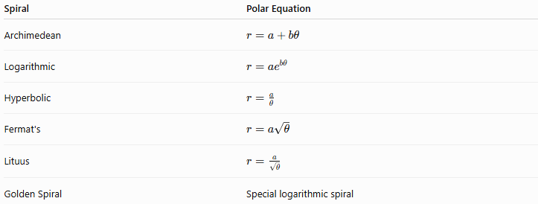
Spiral | Polar Equation
Archimedean | $$r=a+bθ$$
Logarithmic | $$r=ae^{bθ}$$
Hyperbolic | $$r=\frac{a}{θ}$$
Fermat's | $$r=a\sqrt{θ}$$
Lituus | $$r=\frac{a}{\sqrt{θ}}$$
Golden Spiral | Special logarithmic spiral

Spiral Construction Using Polar Points
# Source: AI Source: Provided by: [Data Path: Persons Table -> ID Column: 1, Name_En Column: Motasem Essam] -> From: [ChatGPT] on [7/25/2026]
A general graphical construction can use a sequence of points.
Suppose:
$$θ_{0},θ_{1},θ_{2},…,θ_{n}$$
are selected angles.
For each angle, calculate:
$$r_{i}=f\left(θ_{i}\right)$$
Then construct:
$$P_{i}=\left(r_{i} , θ_{i}\right)$$
Finally, connect:
$$P_{0},P_{1},P_{2},…,P_{n}$$
with a smooth curve.
Thus:
$$\boxed{\text{Spiral}=\text{Progressive Angular Change}+\text{Progressive Radial Change}}$$

Spiral Construction Using Circular Arcs
# Source: AI Source: Provided by: [Data Path: Persons Table -> ID Column: 1, Name_En Column: Motasem Essam] -> From: [ChatGPT] on [7/25/2026]
Some practical geometric spirals can be constructed using connected circular arcs.
Steps
- Establish a center or starting point.
- Construct a sequence of auxiliary points.
- Determine the centers of successive arcs.
- Draw each arc with the required radius.
- Ensure the arcs connect continuously.
- Continue the sequence to form the spiral.
This approach is particularly useful for geometric drawing when an exact analytic spiral is not required.

Spiral Construction Using Squares
# Source: AI Source: Provided by: [Data Path: Persons Table -> ID Column: 1, Name_En Column: Motasem Essam] -> From: [ChatGPT] on [7/25/2026]
A spiral-like curve can also be constructed from a sequence of squares.
Steps
- Construct a starting square.
- Add squares progressively around it.
- Increase or decrease their sizes according to the chosen pattern.
- Divide the squares into appropriate sections.
- Draw arcs through successive square regions.
- Continue the arcs to form a spiral.
This method is commonly associated with Fibonacci/golden-spiral illustrations.

Important Spiral Elements
# Source: AI Source: Provided by: [Data Path: Persons Table -> ID Column: 1, Name_En Column: Motasem Essam] -> From: [ChatGPT] on [7/25/2026]
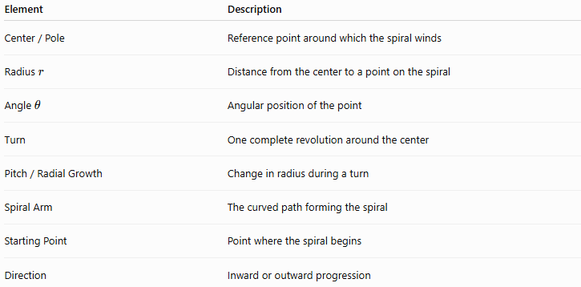
Element | Description
Center / Pole | Reference point around which the spiral winds
Radius $r$ | Distance from the center to a point on the spiral
Angle $θ$ | Angular position of the point
Turn | One complete revolution around the center
Pitch / Radial Growth | Change in radius during a turn
Spiral Arm | The curved path forming the spiral
Starting Point | Point where the spiral begins
Direction | Inward or outward progression

Radial Growth
# Source: AI Source: Provided by: [Data Path: Persons Table -> ID Column: 1, Name_En Column: Motasem Essam] -> From: [ChatGPT] on [7/25/2026]
One important way to distinguish spirals is by how the radius changes.
Constant Additive Growth
For an Archimedean spiral:
$$r=a+bθ$$
The radius increases by a constant amount for equal angular changes.
Constant Multiplicative Growth
For a logarithmic spiral:
$$r=ae^{bθ}$$
The radius changes by a constant ratio for equal angular changes.
This distinction is fundamental:
$$\boxed{\text{Archimedean: constant radial difference}} \\ \boxed{\text{Logarithmic: constant radial ratio}}$$

Spiral Direction
# Source: AI Source: Provided by: [Data Path: Persons Table -> ID Column: 1, Name_En Column: Motasem Essam] -> From: [ChatGPT] on [7/25/2026]
A spiral can progress:
Outward
$$r→∞$$
as the angle increases.
Inward
$$r→0$$
as the angle increases.
The direction depends on the chosen equation and parameterization.

Spiral Symmetry
# Source: AI Source: Provided by: [Data Path: Persons Table -> ID Column: 1, Name_En Column: Motasem Essam] -> From: [ChatGPT] on [7/25/2026]
Spirals generally do not have ordinary reflection symmetry like regular polygons.
Some spirals can have rotational relationships between successive turns.
For example, a logarithmic spiral satisfies a scaling relationship under rotation.
A rotation through a particular angle can correspond to multiplication of the radius by a constant factor.

Spiral vs Circle
# Source: AI Source: Provided by: [Data Path: Persons Table -> ID Column: 1, Name_En Column: Motasem Essam] -> From: [ChatGPT] on [7/25/2026]
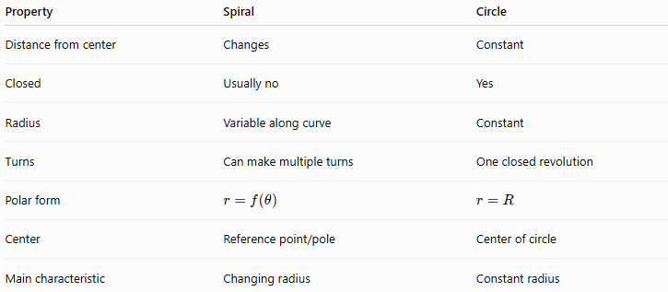
Property | Spiral | Circle
Distance from center | Changes | Constant
Closed | Usually no | Yes
Radius | Variable along curve | Constant
Turns | Can make multiple turns | One closed revolution
Polar form | $$r=f\left(θ\right)$$ | $$r=R$$
Center | Reference point/pole | Center of circle
Main characteristic | Changing radius | Constant radius
A circle can be represented in polar coordinates by:
$$r=R$$
while a spiral requires $r$to vary with $θ$.

Spiral vs Helix
# Source: AI Source: Provided by: [Data Path: Persons Table -> ID Column: 1, Name_En Column: Motasem Essam] -> From: [ChatGPT] on [7/25/2026]
These are different geometric objects.
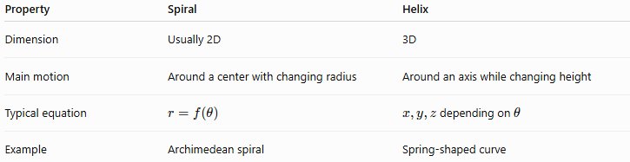
Property | Spiral | Helix
Dimension | Usually 2D | 3D
Main motion | Around a center with changing radius | Around an axis while changing height
Typical equation | $$r=f\left(θ\right)$$ | $x,y,z$depending on $θ$
Example | Archimedean spiral | Spring-shaped curve
A spiral lies in a plane, while a helix generally develops through three-dimensional space.

Construction Classification
# Source: AI Source: Provided by: [Data Path: Persons Table -> ID Column: 1, Name_En Column: Motasem Essam] -> From: [ChatGPT] on [7/25/2026]
The following classification distinguishes the major mathematical spiral families:
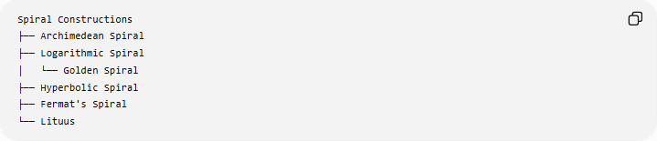
Spiral Constructions
├── Archimedean Spiral
├── Logarithmic Spiral
│ └── Golden Spiral
├── Hyperbolic Spiral
├── Fermat's Spiral
└── Lituus
A broader geometric-construction hierarchy can be written as:
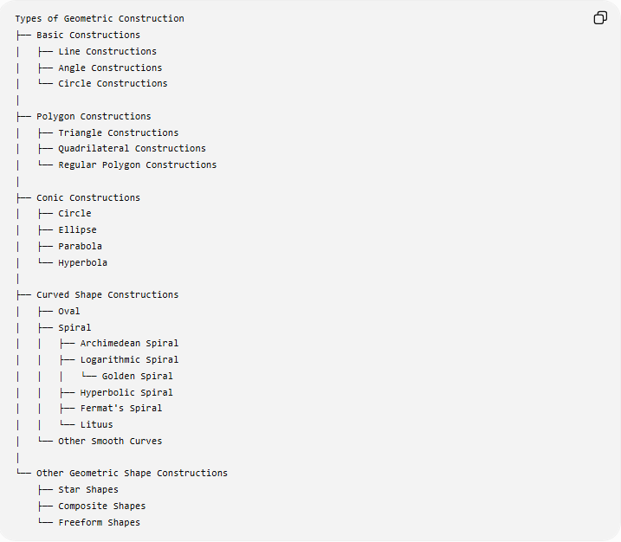
Types of Geometric Construction
├── Basic Constructions
│ ├── Line Constructions
│ ├── Angle Constructions
│ └── Circle Constructions
│
├── Polygon Constructions
│ ├── Triangle Constructions
│ ├── Quadrilateral Constructions
│ └── Regular Polygon Constructions
│
├── Conic Constructions
│ ├── Circle
│ ├── Ellipse
│ ├── Parabola
│ └── Hyperbola
│
├── Curved Shape Constructions
│ ├── Oval
│ ├── Spiral
│ │ ├── Archimedean Spiral
│ │ ├── Logarithmic Spiral
│ │ │ └── Golden Spiral
│ │ ├── Hyperbolic Spiral
│ │ ├── Fermat's Spiral
│ │ └── Lituus
│ └── Other Smooth Curves
│
└── Other Geometric Shape Constructions
├── Star Shapes
├── Composite Shapes
└── Freeform Shapes
Classification note: The five main mathematical families above are standard named spiral types. The Golden Spiral is a special logarithmic spiral, not a separate fundamental spiral family.

Applications
# Source: AI Source: Provided by: [Data Path: Persons Table -> ID Column: 1, Name_En Column: Motasem Essam] -> From: [ChatGPT] on [7/25/2026]
Spiral constructions appear in:
- Geometry.
- Technical drawing.
- Engineering.
- Architecture.
- Mechanical design.
- Decorative design.
- Natural-form modeling.
- Computer graphics.
- Motion and trajectory modeling.
- Optical and electromagnetic designs.
Examples in nature include spiral-like patterns in shells, plants, and certain growth structures, although natural patterns do not necessarily follow an exact mathematical spiral.

Key Points
# Source: AI Source: Provided by: [Data Path: Persons Table -> ID Column: 1, Name_En Column: Motasem Essam] -> From: [ChatGPT] on [7/25/2026]
- A spiral is a curve whose distance from a center changes as its angular position changes.
- Its general polar representation is:
$$\boxed{r=f\left(θ\right)}$$
- An Archimedean spiral has constant radial growth:
$$\boxed{r=a+bθ}$$
- A logarithmic spiral has exponential radial growth:
$$\boxed{r=ae^{bθ}}$$
- A Golden Spiral is a special logarithmic spiral associated with the golden ratio.
- A hyperbolic spiral follows:
$$\boxed{r=\frac{a}{θ}}$$
- Fermat's spiral follows:
$$\boxed{r=a\sqrt{θ}}$$
- A lituus follows:
$$\boxed{r=\frac{a}{\sqrt{θ}}}$$
- Unlike a circle, a spiral does not maintain a constant radius.
- Spiral construction can be performed using rays and calculated points, circular arcs, auxiliary squares, or other geometric methods.

Conclusion
# Source: AI Source: Provided by: [Data Path: Persons Table -> ID Column: 1, Name_En Column: Motasem Essam] -> From: [ChatGPT] on [7/25/2026]
Constructing a Spiral involves creating a curve whose radius changes progressively as it rotates around a center. The construction method depends on the desired spiral family. The principal mathematical types include the Archimedean spiral, logarithmic spiral, hyperbolic spiral, Fermat's spiral, and lituus, with the Golden Spiral being a special logarithmic spiral. The essential construction principle is to control both the angular position and the radial distance of successive points.

